Name: Muhammad Sherjeel Akhtar
Roll No: 20p-0101
Subject: Computer Network Lab
Task No: 3
Submitted To Respect Ma’am: Miss Hurmat Hidayat
Section: B

Task 1: Establish Communication of four devices using Switch.
Answer:
Step 1: Place 4 Pc’s and assign them IP Addresses.
PC 0:
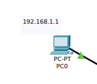

PC 2:
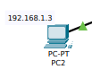

PC 1:
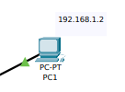
.

PC 3:
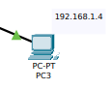
.

Step 2: Place a switch in the centre and connect all four pc’s with the switch using straight copper through cable.
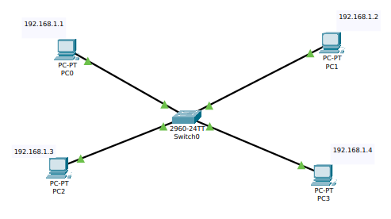
Step 3: Send a packet from PC 0 to PC 3 in order to check whether the connection is successful or not.

.
In the result you can see that our connection is successful.

Task 2: Performing a Communication through multiple Switches.
Answer:
Step 1: Place four PC’s
Step 2: Assign them IP Addresses.
Step 3: Place two switches in the center of four PC’s in a horizontal way.
Step 4: Connect two PC’s from the left side to one switch.
Step 5: Connect two PC’s from the right side to the other switch.
Step 6: Connect both of the switches using Cross Over Cable.
Step 7: Send Packet between two computers.
Step 8: See the results in the Real time Window.

Demonstration:

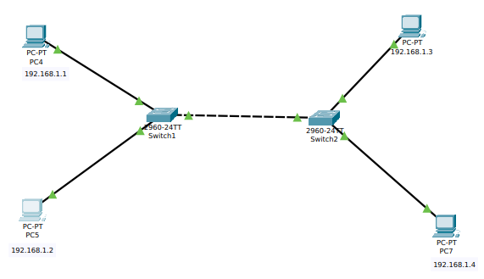
.
Result:

Task 2: Testing the connection b/w two switches by assigning two different IP domains to the respective PC’s.
Answer:
Step 1: Place four PC’s
Step 2: Assign them IP Addresses.
PC4:192.168.1.1
PC5:192.168.1.2
PC6:192.168.2.3
PC7:192.168.2.4
Step 3: Place two switches in the center of four PC’s in a horizontal way.
Step 4: Connect two PC’s from the left side to one switch.
Step 5: Connect two PC’s from the right side to the other switch.
Step 6: Connect both of the switches using Cross Over Cable.
Step 7: Send Packet between two computers.
Step 8: See the results in the Real time Window.

Demonstration:
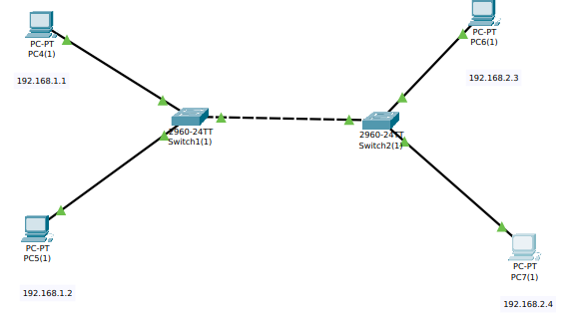

Result:

.
The test will fail because of the different Ranges between the IP Addresses.
Task 3: Establish Connection Between Router and 2 Switches And Connect The Switches With The PC’s.
Answer:
Step 1: Place a Router.
Step 2: Connect two switches with the routers.
Step 3: Connect two PC’s with the left router and assign them IP.
Step 4: Connect two PC’s with the right router and assign them IP.
Step 5: Set the IP in the Router for both of the connections.
First Connection: 192.168.1.10
Second Connection: 192.168.2.10
Step 6: Set 192.168.1.10 as the Default Gateway for the left switch PC’s.
Step 7: Set 192.168.2.10 as the Default Gateway for the right switch PC’s.
Step 8: Send Packets from between the PC’s and demonstrate the results.
Demonstration:
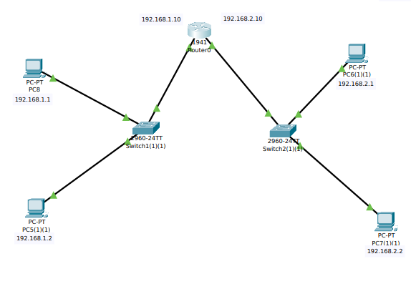
Result:

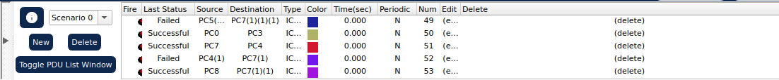
.
Task 4: Test The Static Routing Between 2 Routers.
Answer:
Step 1: Place two routers horizontally.
Step 2: Place two switches and connect one with each router separately.
Step 3: Connect two End PC’s on both sides.
Step 4: Assign the IP to the router.
Step 5: Assign the IP to the End PC’s.
Step 6: Set the default Gateway on PC’s.
Step 7: Send the Packet between the sides.
Demonstration:
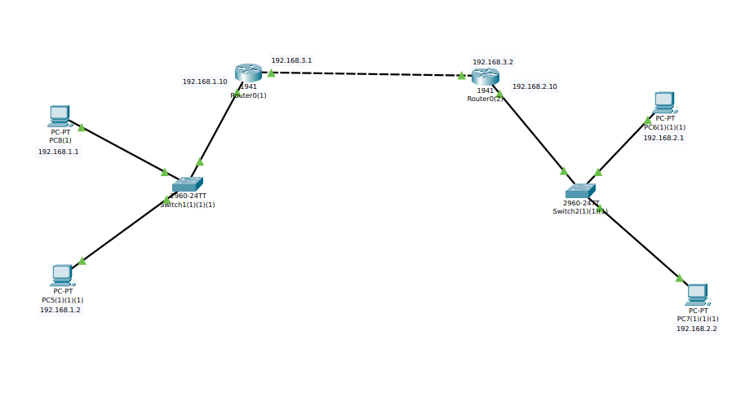

Result:

.
Task 5: Static Routing Between 3 Routers.
Answer:
Step 1: In this we now have 3 routers having a static connection between them so we follow the same
procedure of connecting them and now since we have a third router and switch connected to the pc.
Step 2: We assign them the IP address of 192.168.3.1 and 192.168.3.2 with a gateway of 192.168.3.10 so now
we add two static connection in all the 3 routers so first we use router 0
Step 3: Over there we add a staticconnection from pc 1 to pc 3 so means the packet will hop to router 2 and send that packet and have to return back to pc 1 and the second static address would be for pc 5 so router 1 will hop to router 3 and we will write the same connections for router 2 and router 3 router 2 will send packet back to router 1
and router 3 and router will send packet back to router 2 and router 1
Demonstration:

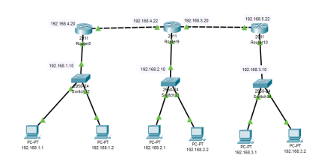
.

Result:

